Install software on laptop
- terminator
  - sudo apt install terminator
- vscode
  - sudo apt install ./code_1.77.3-1681292746_amd64.deb
  - https://code.visualstudio.com/docs/setup/linux
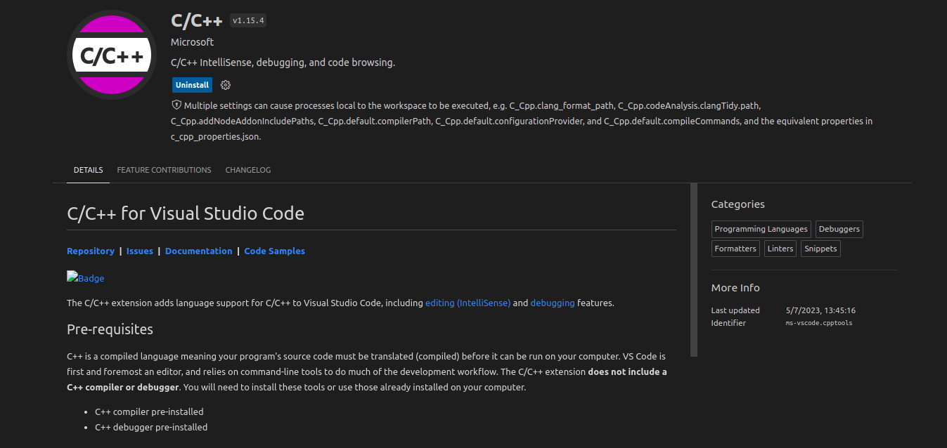
  - install c/c++ intellisense extension

- ifconfig
  - sudo apt install net-tools
- vnc viewer
  - sudo apt install ./VNC-Viewer-7.1.0-Linux-x64.deb
- Install ROS Noetic
  - follow the instrucions here: http://wiki.ros.org/noetic/Installation/Ubuntu
  - to test if ros was install correctly, type the following command in the terminal: rosversion -d

Install required ros packages
- caktin_tools
  - sudo apt install python3-catkin-tools

